North Iowa Community Action Organization Facts

NICAO:
- Is a private, not-for-profit organization governed by a local Board of Directors, 1/3 of whom are elected officials, 1/3 represent the private sector, and 1/3 are consumers of services or elected low-income advocates.
- Maintains office locations and Head Start classrooms in 9 North Central Iowa counties.
- Is one of 18 Community Action agencies in the State of Iowa, part of a national network of Community Action organizations created by the Economic Opportunity Act in 1964.
- Is a United Way Member Agency

Vision and Values:
- Low income people become more self-sufficient and achieve their potential by strengthening family and other supportive environments.
- Low income people have improved living conditions and own a stake in their community.
- Partnerships and community collaborations strengthen services to families, create opportunities to develop new advocates for low income people, and increase the capacity to achieve results.
- The causes and conditions of poverty are addressed through a focus on individual and community needs and community networking.

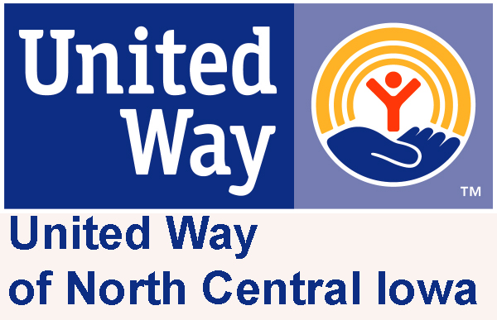

North Iowa Community Action
P.O. Box 1627
Mason City, Iowa, 50402-1627
www.nicao-online.org

ADMN: Fiscal, Planning & Development, LIHEAP, and Provider Claim Systems –
8 AM to 4:30 PM Monday through Friday
218- 5th Street SW, Mason City IA 50401
Phone: 641-423-8993 Fax: 641-494-1716
LIHEAP: 641- 423-9028/ PCS: 641-422-2710

Bridges Mentoring Program
P. O. Box 131, Osage IA 50461
Phone: (641) 732-3566 or (641) 220-3636

Community Partnerships Protecting Children
Suite 104, 218-5th Street SW, Mason City IA 50401
Phone: 641-423-8993 Extension 38

Family Health Center: Maternal and Child Health, I-Smile, hawk-i Outreach, Family Planning and WIC Supplemental Food Program
100-1st Street NW, Suite 200, Mason City IA 50401
Phone: 641-423-5044 Fax: 641-423-0994
Toll Free: 1-800-657-5856

Family Resource Center: Outreach, FaDSS and Community Partners Self Sufficiency Development/Home Visitation Parent Education
1190 Briarstone Drive, Mason City, IA 50401
Phone: 641-423-7766 Fax: 641-423-7767
Toll Free: 1-800-873-1899

Head Start/Early Head Start/Preschool Pathways:
1190 Briarstone Drive, Mason City IA 50401
Phone: 641-494-1891 FAX: 641-494-1894
Toll Free: 1-866-836-3124

Outreach Offices: Algona, Clarksville, Charles City, Forest City, Garner, Hampton, Manly and Osage- call Toll-Free: 1-800-873-1899

Weatherization
2817- 4th Street SE, Mason City, IA, 50401
Phone: 641-424-6453 Fax: 641-424-0636

North Iowa
Community Action
Organization

Incorporated in 1965

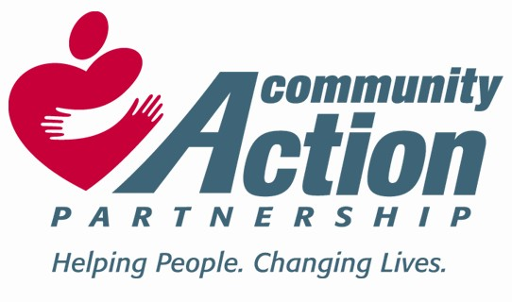

Nine County Regional Service Area Includes: Butler, Cerro Gordo, Floyd, Franklin, Hancock, Kossuth, Mitchell, Winnebago, & Worth Counties

www.nicao-online.org

The Promise of Community Action is to change people’s lives, to embody the spirit of hope, to improve communities, and to make North Central Iowa a better place to live.

MISSION STATEMENT: To enrich the growth and development of children, individuals, and families in North Central Iowa by empowering them to make life-choices which move them all towards self-sufficiency.

Bridges Mentoring Program
Adult mentors spend an hour each week with a child or youth from St. Ansgar, Osage, or Riceville in Mitchell County. Mentors are required to complete background checks, provide references, have a valid driver’s license with insurance, and must complete training before being matched with a child or youth.

Child Health and I-SMILE Program
Children up to the age of 22 have access to Well-Child physical exams, immunizations, vision & hearing assessments, lead screening, dental evaluations, nutrition assessments, & psychosocial & developmental assessments. Services also include the I-Smile Oral Health Program & hawk-i Outreach Program.

Community Partners Self-Sufficiency Development Program
Monthly home visits to address the needs of families experiencing financial challenges and barriers to self-sufficiency. Partnership with Mercy Medical Center - North Iowa.

Community Partners: Home Visitation, Parent Education and Family Support Program - to address the needs of families with children providing monthly home visits with parent educators. Services are voluntary and free of charge to participants.

Community Coordination of Families Making Connections and Partners 4 Children Decategorization Contracts with DHS.

CPPC - Community Partnerships for Protecting Children: Community Networking, Shared Decision Making, Policy & Practice Change and Family Team Meetings or Family Team Conferencing in Cerro Gordo, Hancock, Winnebago and Worth counties.

FaDSS: Family Development and Self Sufficiency for FIP Recipients
Home visits scheduled a minimum of twice a month with Family Development Specialists to assist families in moving successfully from FIP to employment represents a successful partnership with DHS and PROMISE JOBS.

Financial Assistance

Assistance may be available to eligible households to assist with emergency rent, mortgage payments or utility bills as well as with security deposits to prevent homelessness. Repayments may be required.

Family Planning
Clinical services are available to both males and females and include: birth control exams, tests and treatment for STIs, cancer screening, pap smears, breast exams, and pregnancy tests. Costs are based on ability to pay, and are often less than other health centers.

Head Start
Comprehensive early childhood development program for 3 and 4 year old children and children with special needs. Early Head Start: Home Visits (Birth to 3) in Floyd, Mitchell, and Chickasaw counties.

Low Income Home Energy Assistance
Assistance with winter heating costs, emergency fuel deliveries, emergency furnace repairs and/or furnace replacements..

Maternal Health
Prenatal and postpartum care including medical and dental assessment, health and nutrition education, psychosocial screening and referral, coordination of care, and assistance with plans for delivery available for Medicaid eligible and other low income women.

OUTREACH Offices in each County

Provide information & referral services as well as access to emergency financial assistance for basic necessities including food, shelter and utilities.

Preschool Pathways
A parent education program for families of preschool children (3 to 5 years of age) living in Cerro Gordo, Hancock, and Worth counties. Parents attend a series of weekly classes focusing on parenting skills.

Provider Claim Systems
Processing claims for reimbursement and activity reporting for the Breast and Cervical Cancer Early Detection Program, WISEWOMAN, Susan G. Komen Breast Screening Project, IGS, and the Child Audiological Services and Hearing Aids Program for the Iowa Department of Public Health.

VITA Free Tax Preparation Services
A partnership between NICAO and the North Iowa Tax Coalition providing free tax preparation services to income eligible low to moderate income households during February and March in Mason City, Algona and Forest City.

Weatherization
Weatherizes homes and provides residential health and safety analysis, technical energy conservation measures, and leakage reduction through high-density insulation to qualified households.

WIC (Women, Infants, & Children)
Nutrition education and supplemental nutritional foods are made available to pregnant, breastfeeding, or postpartum women, infants and children up to age of 5 years.

